**DAILY ONLINE ACTIVITIES SUMMARY**

|  |  |  |  |  |  |  |  |  |
| --- | --- | --- | --- | --- | --- | --- | --- | --- |
| **Date:** | **27/05/2020** | | | | | **Name:** | **Katira Krishna J** | |
| **Sem & Sec** | **8th A** | | | | | **USN:** | **4AL16CS045** | |
| **Online Test Summary** | | | | | | | | |
| **Subject** | | **IOT** | | | | | | |
| **Max. Marks** | | **30** | | **Score** | | | **28** | |
| **Certification Course Summary** | | | | | | | | |
| **Course** | **Machine learning with python** | | | | | | | |
| **Certificate Provider** | | | **Cognitiveclass.ai** | | **Duration** | | | **12 Hours** |
| **Coding Challenges** | | | | | | | | |
| **Problem Statement:**  implement bubble sort using python | | | | | | | | |
| **Status: Completed** | | | | | | | | |
| **Uploaded the report in Github** | | | | | **yes** | | | |
| **If yes Repository name** | | | | | **Krishna_Katira** | | | |
| **Uploaded the report in slack** | | | | | **yes** | | | |

Online Test Details:

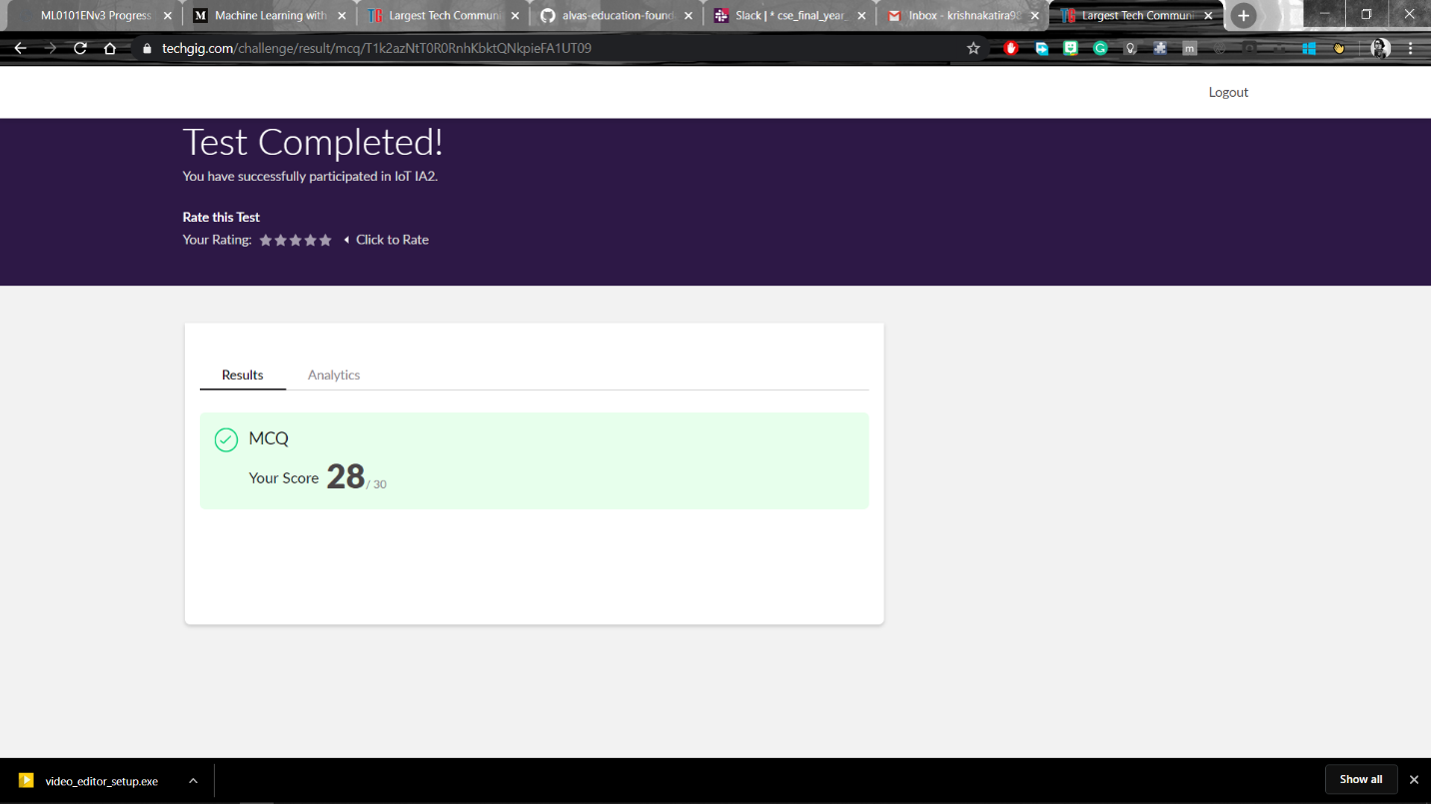

Certification Course Details:

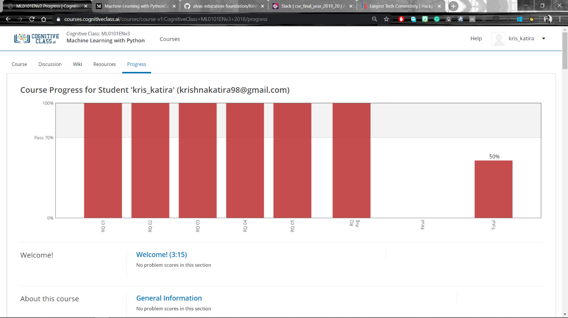

Coding Challenges Details:

**program1**

def bubbleSort(arr):

    n = len(arr)

    for i in range(n-1):

        for j in range(0, n-i-1):

            if arr[j] > arr[j+1] :

                arr[j], arr[j+1] = arr[j+1], arr[j]

arr = [64, 34, 25, 12, 22, 11, 90]

bubbleSort(arr)

print ("Sorted array is:")

for i in range(len(arr)):

    print ("%d" %arr[i]),